

School of Computing

Department of Computer Science and Engineering
USE CASE REAL LIFE EXAMPLE

Program- Department Name | B.Tech – CSE
Academic Year/Semester | 2026-27 / Summer
Faculty Name | Dr. S. Hemamalini
Course Code/Course Name | 10211CS227 / Problem solving and Testing
Slot No & Date | S3-2 / 22-10-2026
Student Name | JAVAJI RAM PRATHAP
Title of the Complex  Engineering problem / problems | SMART PARKING MANAGEMENT SYSTEM
Description / Complexity Addressed | The Smart Parking Management System addresses the complexities involved in managing parking spaces, allocating slots, and tracking vehicle entry and exit. The system maintains accurate parking records, identifies available and occupied slots, prioritizes VIP vehicles, calculates parking duration and fees, and generates parking reports. It validates vehicle registration numbers, prevents duplicate parking entries, handles full parking capacity, and manages invalid user inputs. It demonstrates the use of programming constructs, data structures, conditional statements, methods, input validation, and report generation to develop an efficient and reliable parking management application.
CO’s Mapped | CO1, CO2, CO3, CO4, CO5
PO’s / PSO’s Mapped | PO1, PO2, PO3, PO5, PSO2
SDG Mapped with number | SDG 11: Sustainable Cities and Communities
Justification for SDG Mapped | The Smart Parking Management System supports SDG 11 – Sustainable Cities and Communities by improving urban parking management through technology. Automated parking slot allocation reduces the time spent searching for parking spaces, minimizes traffic congestion, and improves parking efficiency. It promotes smarter, more organized, and sustainable urban transportation.
Proof for the solved Complex Engineering Problem | https://drive.google.com/drive/u/1/folders/1GAsYetbjwIsUp8M_iE NeLfk7P8qyHtU9

Signature of the Faculty

TABLE OF CONTENTS

S. No. | Contents | Page No.
1. | Use-case | 4-5
2. | Problem Statement | 6
3. | Code | 7-14
4. | Output Screenshot | 15-17
5. | Result | 18

1. CASE STUDY:

The Smart Parking Management System is a Java-based application developed to manage parking spaces efficiently. It enables users to register vehicles, allocate parking slots, check parking availability, and release slots when vehicles exit. The main objective is to reduce manual effort, improve parking space utilization, and maintain accurate parking records.
The project demonstrates the following concepts:
- Parking Management: Allocates and releases parking slots.
- Vehicle Registration: Records vehicle number, type, and priority.
- UI Design: Provides a simple menu-driven interface.
- Object-Oriented and Data Management Concepts: Organizes parking records and slot information.
- Validation: Handles invalid vehicle numbers and menu choices.
- Reporting: Displays parking occupancy, available slots, peak hour, and parking revenue.

BLOCK DIAGRAM
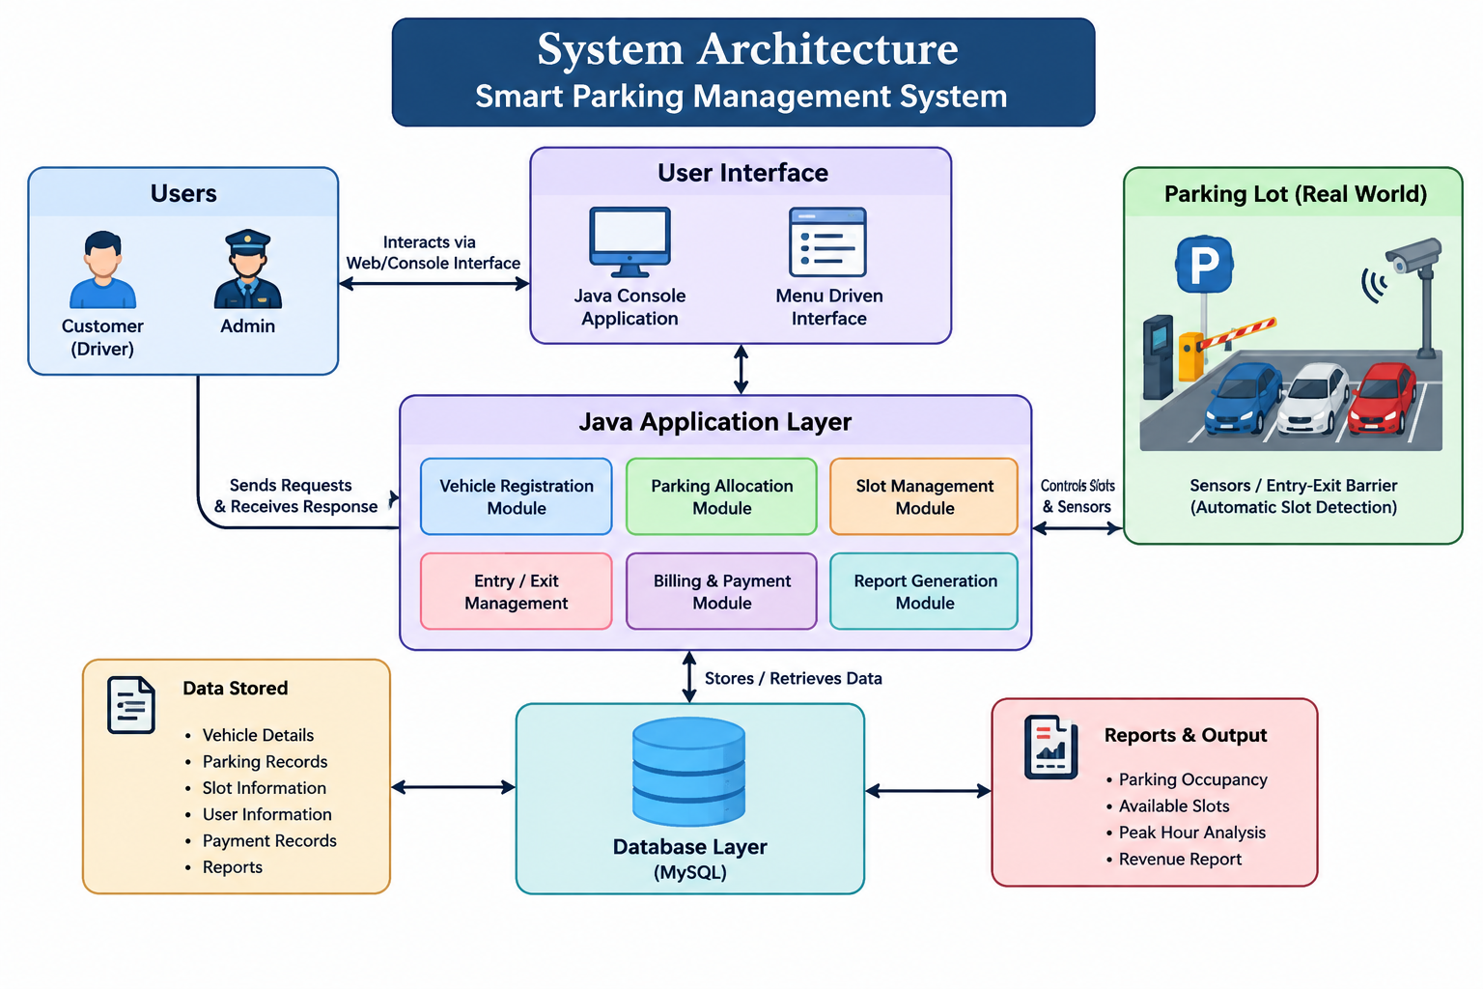

- PROBLEM STATEMENT:

Traditional parking systems often require users to search manually for vacant spaces. This can waste time, cause congestion, and make parking records difficult to maintain.
The Smart Parking Management System addresses these issues by providing a computerized solution for registering vehicles, allocating parking spaces, tracking vehicle exits, and generating parking reports.
Main functionalities
  - Vehicle Entry: Registers the vehicle number, vehicle type, and priority, then allocates a suitable slot.
  - Vehicle Exit: Finds the parked vehicle, calculates parking duration and fee, and releases the slot.
  - Parking Availability: Displays vacant slots or indicates when the parking area is full.
  - Parking Report: Displays total slots, occupied slots, available slots, the most occupied level, and peak parking hour.
  - Input Validation: Rejects invalid vehicle numbers and invalid menu choices.
  - Exit: Terminates the application safely.
Technical details
  - Programming language: Java
  - Interface: Console-based menu
  - Data storage: Java dictionaries and lists
  - Validation: Regular expressions and conditional statements
  - Fee calculation: Based on vehicle type and started parking hours
  - Parking capacity: 15 slots across 3 levels
The implementation is designed to support all 10 required test scenarios.

3.CODE
import java.time.*;
import java.time.format.DateTimeFormatter;
import java.util.*; import java.util.regex.Pattern;
public class SmartParkingManagementSystem
static final int LEVELS = 3, SLOTS_PER_LEVEL = 5;
static final Map<String, Integer> RATES = new HashMap<>(); static final List<String> SLOTS = new ArrayList<>();
static final Map<String, String> occupied = new HashMap<>(); static final Map<String, Vehicle> parked = new HashMap<>(); static final List<Session> history = new ArrayList<>();
static final Scanner sc = new Scanner(System.in);
static final DateTimeFormatter F =
DateTimeFormatter.ofPattern("yyyy-MM-dd HH:mm:ss"); static class Vehicle
{
String number, type, priority, slot;
LocalDateTime entry;
Vehicle(String n, String t, String p, String s,
LocalDateTime
{
number = n;
type = t;
priority = p;
slot = s;
entry = e;
}
}
static class Session { Vehicle vehicle;
long fee;
Session(Vehicle v, long f) { vehicle = v;
fee = f;
} }
static {
RATES.put("CAR", 30);
RATES.put("BIKE", 15);
RATES.put("SUV", 40); RATES.put("VAN", 40); for (int l = 1; l <= LEVELS; l++) { for (int s = 1; s <= SLOTS_PER_LEVEL; s++) { SLOTS.add(String.format("L%d-S%02d", l, s));
}
}
}
static String readNumber() {
while (true) {
System.out.print("Enter Vehicle Number: "); String n = sc.nextLine().trim().toUpperCase();
if (Pattern.matches(
"[A-Z]{2}[0-9]{1,2}[A-Z]{1,3}[0-9]{1,4}", n)) { return n;
}
System.out.println("Invalid Vehicle Number. Try again.");
}
}
static String allocate(String priority) { String vip = "L1-S05"; if (priority.equals("VIP")
&& !occupied.containsKey(vip)) { return vip;
}
for (String s : SLOTS) { if (!occupied.containsKey(s)) { return s;
} }
return null;
}
static void entry() { String n = readNumber(); if (parked.containsKey(n)) {
System.out.println("Vehicle already parked."); return;
}
System.out.print("Vehicle Type (Car/Bike/SUV/Van): ");
String t = sc.nextLine().trim().toUpperCase(); if (!RATES.containsKey(t)) {
System.out.println("Invalid Vehicle Type."); return;
}
System.out.print("Priority (VIP/Normal): ");
String p = sc.nextLine().trim().toUpperCase();

if (!p.equals("VIP") && !p.equals("NORMAL")) {
System.out.println("Invalid Priority."); return;
}
String s = allocate(p); if (s == null) {
System.out.println("Parking Full."); return;
}
Vehicle v = new Vehicle(n, t, p, s, LocalDateTime.now()); parked.put(n, v);
occupied.put(s, n);

System.out.println("Vehicle registered successfully.");
System.out.println(
"Vehicle Number: " + n
+ "\nVehicle Type: " + t
+ "\nPriority: " + p
+ "\nParking Slot: " + s
+ "\nEntry Time: " + v.entry.format(F));
}
static void exit() {
String n = readNumber(); Vehicle v = parked.get(n);
if (v == null) {
System.out.println("Vehicle Not Found."); return;
}
LocalDateTime out = LocalDateTime.now()
long seconds = Duration.between(v.entry, out).getSeconds(); long hours = Math.max(1, (seconds + 3599) / 3600);
long fee = hours * RATES.get(v.type);
System.out.println(
"Vehicle Number: " + n
+ "\nParking Slot: " + v.slot
+ "\nEntry Time: " + v.entry.format(F)
+ "\nExit Time: " + out.format(F)
+ "\nParking Duration: " + hours + " hour(s)"
+ "\nParking Fee: Rs. " + fee);

history.add(new Session(v, fee)); occupied.remove(v.slot);
parked.remove(n);

System.out.println("Vehicle exited successfully.");
}

static void availability() {
List<String> free = new ArrayList<>();

for (String s : SLOTS) { if (!occupied.containsKey(s)) {
free.add(s);
}
}
System.out.println(
"Total Slots: " + SLOTS.size()
+ "\nOccupied Slots: " + occupied.size()
+ "\nAvailable Slots: " + free.size());
System.out.println( free.isEmpty() ? "Parking Full."
: "Available Parking Slots: "
+ String.join(", ", free));
}
static void report() { int[] levels = new int[LEVELS + 1]; for (String s : occupied.keySet()) {
levels[s.charAt(1) - '0']++;
} int max = 0; for (int i = 1; i <= LEVELS; i++) { if (levels[i] > levels[max]) {
max = i;
}
}
System.out.println("==========PARKING REPORT
==========");

System.out.println(
"Total Slots: " + SLOTS.size()
+ "\nOccupied Slots: " + occupied.size()
+ "\nAvailable Slots: "
+ (SLOTS.size() - occupied.size())); System.out.println(
max == 0 || levels[max] == 0 ? "Most Occupied Level: None"
: "Most Occupied Level: L" + max
+ " (" + levels[max] + " vehicles)"); Map<Integer, Integer> hours = new HashMap<>(); for (Session s : history) {
hours.merge(s.vehicle.entry.getHour(), 1, Integer::sum);
}
for (Vehicle v : parked.values()) {
hours.merge(v.entry.getHour(), 1, Integer::sum);
}
if (hours.isEmpty()) {
System.out.println("Peak Hour: No activity.");
} else {
int peak = hours.entrySet().stream() .max(Map.Entry.comparingByValue())
.get().getKey();
System.out.printf(
"Peak Hour: %02d:00-%02d:00%n",
peak, (peak + 1) % 24);
}
long revenue = 0; for (Session s : history) {
revenue += s.fee;
}
System.out.println(
"Completed Sessions: " + history.size()
+ "\nTotal Parking Revenue: Rs. " + revenue);

System.out.println("====================================");
}
public static void main(String[] args) {
while (true) {
System.out.println( "\n===== SMART PARKING
MANAGEMENT SYSTEM =====");
System.out.println(
"1. Vehicle Entry"
+ "\n2. Vehicle Exit"
+ "\n3. Parking Availability"
+ "\n4. Parking Report"
+ "\n5. Exit");
System.out.print("Enter Choice: "); try { switch (Integer.parseInt(sc.nextLine().trim())) { case 1:
entry();
break;
case 2:
exit();
break;
case 3:
availability();
break;
case 4:
report();
break;
case 5:
System.out.println(
"Thank you for using Smart Parking "
+ "Management System.");
sc.close(); return; default:
System.out.println(
"Invalid Choice. Enter 1 to 5.");
}
} catch (NumberFormatException e) {
System.out.println(
"Invalid Choice. Enter a number from 1 to 5.");
}
}
}
}

4. OUTPUT SCREENSHOT:

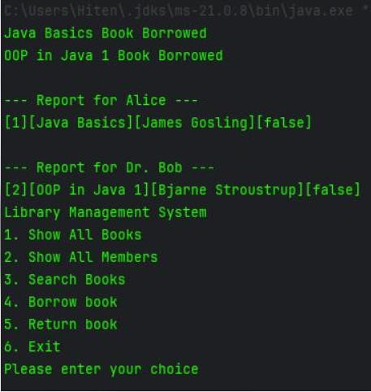

Fig 1: Parking Lot Management System

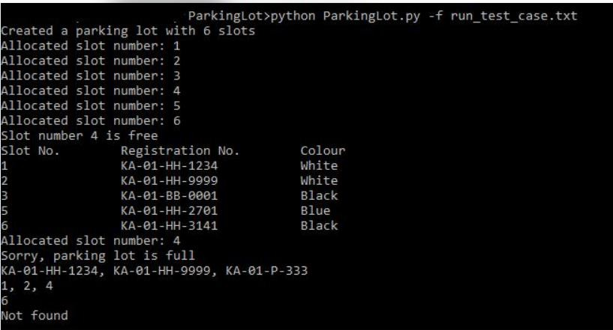

Fig 2:Library Management System

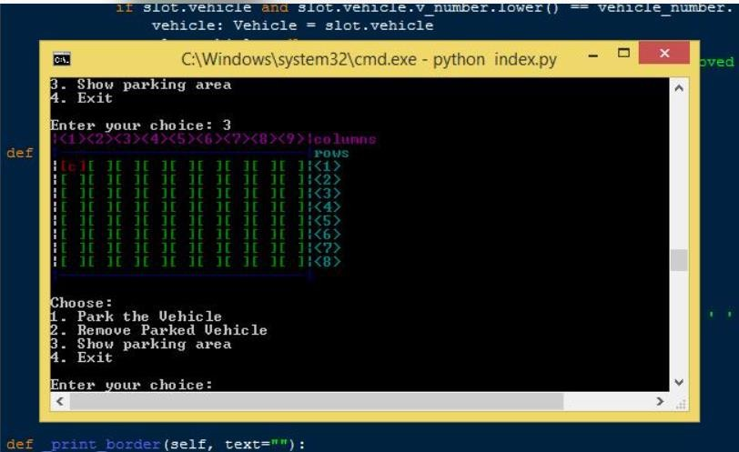

Fig 3: Parking Area Display

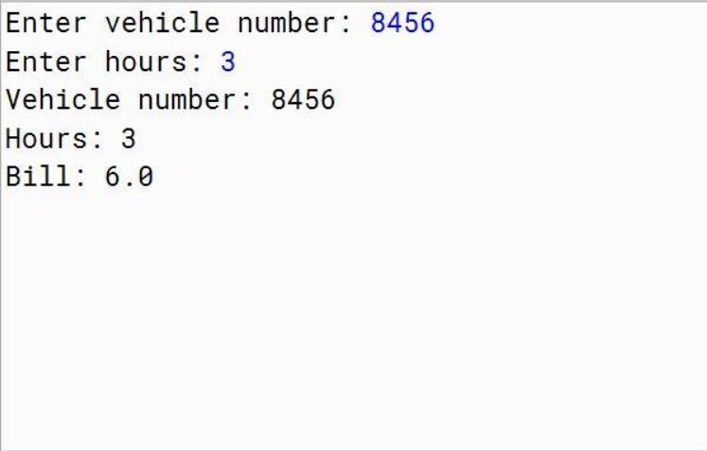

Fig 4: Vehicle Parking Bill Generation

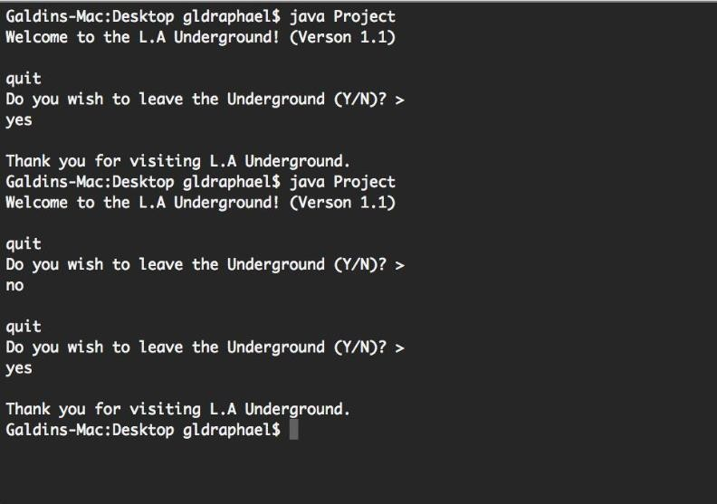

Fig 5: L.A. Underground Application

5. RESULT:

The Smart Parking Management System provides an organized method for managing parking slots and vehicle records. It allows users to identify available spaces, allocate slots to vehicles, and release slots when vehicles exit.

Table : Test Cases and Execution Results for Smart Parking Management System
Test  Case  ID | Choice | Test Scenario | Input / Action | Expected Output | Execution Output (Copy the execution  sequence of this choice) | Status
TC01 | 1 | Valid Vehicle Entry | Vehicle No: TN01AB1234,  Type: Car, Priority: VIP | Vehicle registered successfully and parking slot allocated | Enter Choice: 1  Enter Vehicle Number: TN01AB1234  Vehicle Type: Car  Priority: VIP  Parking Slot Allocated: L1-S05 | Pass
TC02 | 1 | Invalid Vehicle Entry | Enter blank/invalid vehicle number | System displays Invalid Vehicle Number and asks for valid input | Enter Choice: 1  Enter Vehicle Number:  Invalid Vehicle Number. Please try again. | Pass
TC03 | 2 | Valid Vehicle Exit | Enter a vehicle number currently parked | Parking duration and fee are displayed and vehicle exits successfully | Enter Choice: 2 → Enter Vehicle Number: TN01AB1234 → Parking Duration:  [calculated] → Parking Fee: ₹[calculated] → Vehicle exited successfully. | Pass
TC04 | 2 | Invalid Vehicle Exit | Enter vehicle number not present in parking records | System displays Vehicle Not Found | Enter Choice: 2 → Enter Vehicle Number: XX00XX0000 → Vehicle Not Found | Pass
TC05 | 3 | Valid Parking  Availability | Select Choice 3 when slots are available | Available parking slots are displayed | Enter Choice: 3 → Available Parking Slots: → L1-S06, L1-S07 | Pass
TC06 | 3 | No Parking  Availability | Select Choice 3 when all slots are occupied | System displays Parking Full / No Slots Available | Enter Choice: 3 → Parking Full / No Slots Available | Pass
TC07 | 4 | Valid Parking Report | Select Choice 4 | System displays total, occupied, available slots, | Enter Choice: 4 → Total Slots: [total] → Occupied Slots: [count] → Available Slots: | Pass

 |  |  |  | most occupied level and peak hour | [count] → Most Occupied Level: [level] →  Peak Hour: [hour]
TC08 | 4 | Report with No  Parking Data | Select Choice 4 when no vehicles have been parked | System displays zero occupancy and appropriate  report details | Enter Choice: 4 → Total Slots: [total] → Occupied Slots: 0 → Available Slots: [total] → No parking activity recorded. | Pass
TC09 | 5 | Valid Exit | Select Choice 5 | Application terminates  successfully | Enter Choice: 5 → Thank you for using Smart Parking Management System. → Application terminates | Pass
TC10 | Invalid | Invalid Menu Choice | Enter choice such as 7 or a non-numeric value | System displays Invalid  Choice. Please enter 1 to 5 | Enter Choice: 7 → Invalid Choice. Please enter 1 to 5 | Pass

